Effective January 1st 2024 any Domestic Corporation, LLC, L.P., or Foreign entity will be required to file a Beneficial Ownership Report that will identify information about itself, individuals who directly or indirectly own or a control a company herein known as Beneficial Owners, and individuals involved in the formation of the company herein known as company applicants. This is a requirement for ALL identified companies, and there is no fee to file. These companies are herein known as reporting companies.

There are a small group of companies such as tax-exempt entities that will not have to report. If you have a question about if your company is exempt from Beneficial Ownership reporting please go to [www.fincen.gov/boi](http://www.fincen.gov/boi).

All reporting companies formed PRIOR to January 1st 2024 will have until January 1st 2025 to file their first Beneficial Ownership report. Companies formed PRIOR to January 1st 2024 will NOT be required to report information on company applicants. All beneficial ownership reports have to be filed on www.fincen.gov/boi.

Any reporting company filed AFTER January 1st 2024 will have 90 days from the date of formation to file their first Beneficial Ownership report. We recommend filing within 30 days from submitting the filing in order to be in compliance. All beneficial ownership reports have to be filed on [www.fincen.gov/boi](http://www.fincen.gov/boi).

*All companies who do not comply with Beneficial Ownership obligations and reporting are subject to civil and criminal penalties.

What is Included in A Beneficial Ownership Report?

The Beneficial Ownership Report will include information about the company such as the name, DBA, TA, address of principal place of business, jurisdiction of formation, and EIN/TIN.

The Beneficial Ownership Report will require information regarding individuals who directly exercises substantial control (such as the company’s president, CEO, CFO, individuals who can appoint or remove officers, and individuals who are important decision makers). The Report will also require information regarding individuals who owns or controls at least 25% of the company’s ownership interests. This information is to include the name, date of birth, residential address (cannot be a P.O. Box), and identifying number from an identification document such as a driver’s license or passport.

* For an exhaustive list of acceptable documents visit [www.fincen.gov/boi](http://www.fincen.gov/boi).
* For an exhaustive list of who is considered an individual with direct or indirect beneficial ownership please visit [www.fincen](http://www.fincen).gov/boi.
* There are five exceptions to an individual having to be included in the Beneficial Ownership Report. If you have a question about if an individual is exempt please go to [www.fincen](http://www.fincen).gov/boi.

For reporting companies formed AFTER January 1st 2024, the Beneficial Ownership Report will also require information on company applicants such as (the individual who files the formation and/or the initiator of the filing. This information is to include the name, date of birth, residential address (it cannot be a P.O. Box), and an identifying number from an identification document such as a driver’s license or passport.

* Please see [www.fincen.gov/boi](http://www.fincen.gov/boi) for questions about who is considered a company applicant.
* An exhaustive list of acceptable documents are specified on the [www.fincen](http://www.fincen).gov/boi.

Important Things to Note

* If there are changes to Beneficial Ownership information such as an amendment to the company name, a change in beneficial owners, or changes to owner’s names/addresses/identifying document numbers, all changes to Beneficial Ownership information MUST be reported within 30 days of the change.
* If an error on the Beneficial Ownership Report is identified, all changes MUST be reported within 30 days via a corrected report filed on the www.fincen.gov/boi.
* All companies who do not comply with Beneficial Ownership obligations and reporting are subject to civil and criminal penalties.
* Reporting companies will have the option of applying for a FinCEN identifier that will provide them a unique identifying number in lieu of having to provide personal information during reporting. For more information on FinCEN identifiers please visit www.fincen.gov/boi.

Continue to go to [www.fincen.gov/boi](http://www.fincen.gov/boi) for updates, as changes and updates to the process are expected within the first year or so as this new process is implemented.

This notification does not replace guidance from legal counsel and examination of the rules and regulations posted on the FinCEN website, [www.fincen.gov/boi](http://www.fincen.gov/boi).

Any company that fails to file a required beneficial ownership report or amendment by its filing deadline is subject to a fine of $500 per day, up to a maximum of $10,000. Willful failures or intentionally filing inaccurate information is a felony, punishable by up to two years in prison.

Who is a Beneficial Owner?

A Beneficial Owner is an individual who directly exercises substantial control (such as the company’s president, CEO, CFO, individuals who can appoint or remove officers, and individuals who are important decision makers). The Report will also require information regarding individuals who owns or controls at least 25% of the company’s ownership interests.

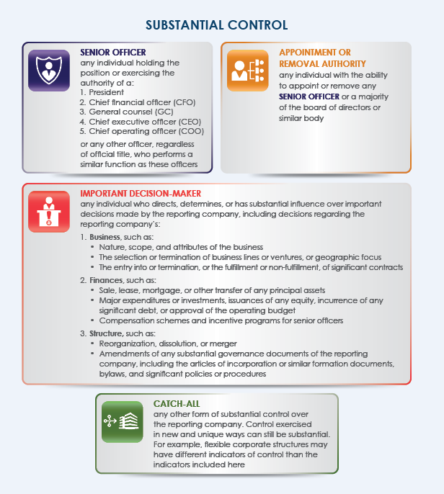

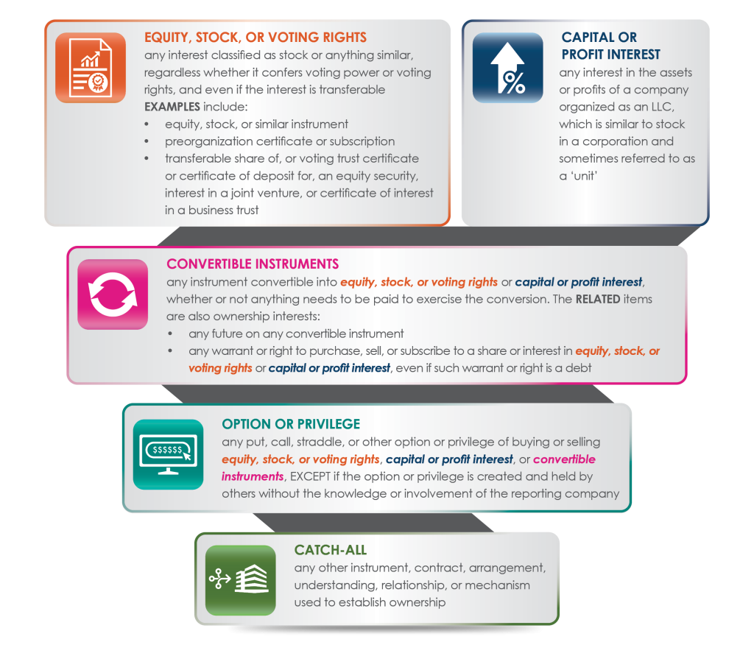

Who is a Company Applicant?

A Company Applicant is an individual such as the person who files the formation and/or the initiator of the filing. There may be more than one company applicant (a limit of two) which is the person responsible for initiating the filing, and the person who files the document to form the company (such as a Registered Agent).

